Pourato Decision Request
  - Moving from ask-only advice to supervised agentic development assistance
Decision sought. Approval is sought for the Pourato Delivery Team to progress from the ask-only AI assistance provided through the current AI pilot to controlled agentic AI use within development environments. The request is limited to supervised development work in non-production environments, using source-controlled code repositories, existing user permissions, and existing development and release controls. The purpose is to support agreed Pourato obligations for two groups: C&A stakeholders, who require improved safety, compliance, accreditation confidence, and controlled risk; and business stakeholders, who require expected service-provider functionality and completion of agreed system outcomes.
The current pilot has demonstrated value from ask-only advisory assistance. The decision required here is whether Pourato may use controlled agentic development assistance within Visual Studio, either because this is confirmed as permitted within the current pilot or policy settings, or because a targeted exception is approved. In this paper, agentic assistance means the tool can prepare candidate development changes in the development environment, but a developer must review, accept, test, and submit any change through the normal pathway.

Rationale
Why this is needed. Pourato is expected to deliver agreed outcomes for both C&A and business stakeholders. For C&A, those outcomes include improved safety, improved compliance, accreditation confidence, and controlled risk. For business stakeholders, they include expected service-provider functionality, completion of agreed delivery scope, and reduced reliance on ERS Legacy. Those outcomes depend on practical system change: advisory AI can help developers and analysts understand unfamiliar code and investigate support issues, but it does not materially reduce the effort required to construct, test, refactor, and validate working code.
The current position is that Pourato has moved into business-as-usual operation while still carrying material undelivered functionality and migration work from ERS Legacy. C&A coverage by exemption for the legacy system is only until December 2026, creating a time-bound need to complete the development and migration work required to move off that system. This creates a delivery gap. The remaining work requires practical implementation capacity, including interpretation of legacy behaviour, code construction, test creation, refactoring, impact assessment, and validation across related components.
A current example is the remaining migration work from ERS Legacy, including ARTF and requests-related functionality. That work requires legacy behaviour to be understood, implemented or modified in code, covered by tests, and validated through the normal staged pathway. It is execution-heavy system development work, not simply investigation.
Observed gains. During the current funding cycle, AI-assisted investigation identified in less time the main cause and resolution of poor RS7 import performance after previous manual investigation in two earlier rounds had not resolved the cause. This is not yet a quantified time or cost saving, but it demonstrates improved problem isolation where legacy behaviour, performance issues, and system interactions are difficult to trace.
Expected gains. Controlled agentic AI is expected to increase practical implementation capacity within existing controls by helping developers prepare first-pass code, tests, refactoring, and impact analysis faster and more consistently than purely manual effort. Any quantified time or cost benefit should be added only when supported by evidence from comparable Pourato tasks, pilot observations, or developer estimates.
The expected benefits are improved delivery throughput, better test creation, faster impact assessment, more consistent refactoring, better use of limited system knowledge, and reduced avoidable manual effort, without changing accountability or release governance.
Impact if not approved. If controlled agentic AI is not approved, Pourato remains dependent on advisory AI and existing manual development capacity. The remaining implementation work still needs to be completed through the current delivery model, with a higher likelihood of delay, reduced scope, slower defect remediation, and reduced confidence that Pourato can meet agreed objectives within expected timeframes.
This is therefore a controlled delivery-enablement request tied to already-agreed Pourato outcomes, not a request to replace developer judgement, accountability, or release governance.
Proposed scope. The proposed use is deliberately constrained. It applies only to Pourato development activities. It applies only in non-production development environments. It applies to source code and related development artefacts, not general organisational data. It operates within source-controlled repositories and normal development tooling. It is a request for controlled agentic development assistance, not wider autonomous organisational action.
The agent would assist with code-related development tasks under direct human supervision. It would not operate production systems. It would not make release decisions. It would not bypass existing approval, testing, change, or deployment controls.
The approval should be team-scoped, not limited to a single named user. In practice, the Pourato development pool is small, with only around half of the four-developer team expected to undertake this new development work at any one time. This keeps use deliberately contained to a small supervised group while avoiding an artificial single-user dependency.
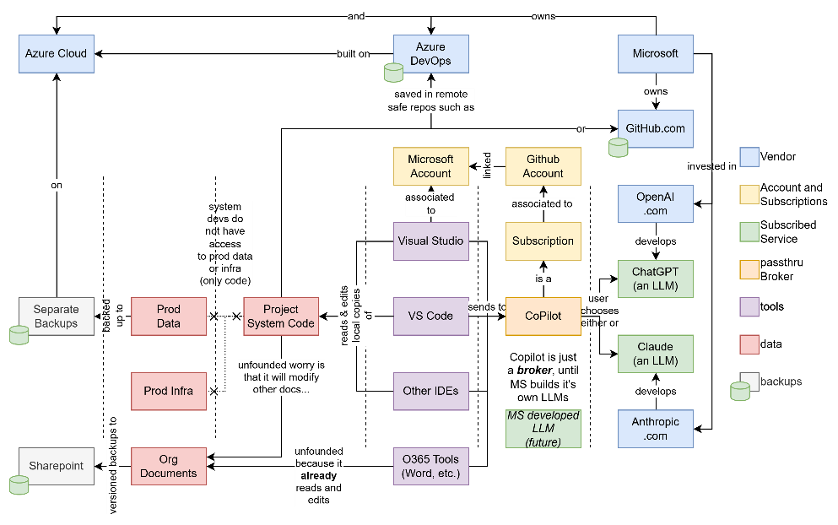
Figure 1: AI integration in an organisational context
Controls. The proposed use sits inside the same controlled development context already used by Pourato developers. Developers work on source-controlled code, not production systems. Code changes are reversible, must pass review, automated tests, and deployment pipelines, and progress through staged environments before production. Developers do not have access to production data.
Within that context, agentic AI should be understood as a supervised development effort multiplier, not an autonomous decision-maker. It increases the amount of code navigation, candidate implementation, test preparation, refactoring, and impact tracing a developer can undertake within the same development environments, permissions, source control, review, testing, and staged release controls already used for Pourato. It replaces part of the supervised work effort -- not the judgement, approval, release governance, or accountability.
The control pathway is therefore materially the same as for ordinary development work. A proposed code change must be accepted by the developer, committed to source control, pass the relevant test and build automation, and move through system test, user test, and pre-production before it can reach production.
Data access remains subject to existing environment and access controls. Production data is not required for the proposed use. Where non-production data is involved, it remains within controlled and restorable development contexts.
Residual risk and mitigation. The residual risk is not that agentic AI can independently operate Pourato, deploy changes, alter production data, or alter organisational sensitive documents. The proposed controls do not provide that pathway. The residual risk is that it may suggest incorrect, incomplete, insecure, or unsuitable code. That is a development-quality risk managed through the existing development controls described above.

Recommendation
Approval is recommended for controlled agentic AI use by the Pourato Delivery Team within the proposed scope, limited to supervised development activity in non-production environments using existing permissions, human review, testing, release, and change controls.
If approval is not given, the delivery risk remains for both C&A and business obligations, while the avoided AI risk is limited because the requested use is already controlled and bounded.

